EXP 5
IMPLEMENTATION OF RAIL FENCE – ROW & COLUMN
TRANSFORMATION TECHNIQUE

AIM:
To write a C program to implement the rail fence transposition technique.

ALGORITHM:

STEP-1: Read the Plain text.
STEP-2: Arrange the plain text in row columnar matrix format.
STEP-3: Now read the keyword depending on the number of columns of the plain text.
STEP-4: Arrange the characters of the keyword in sorted order and the corresponding
columns of the plain text.
STEP-5: Read the characters row wise or column wise in the former order to get the
cipher text.

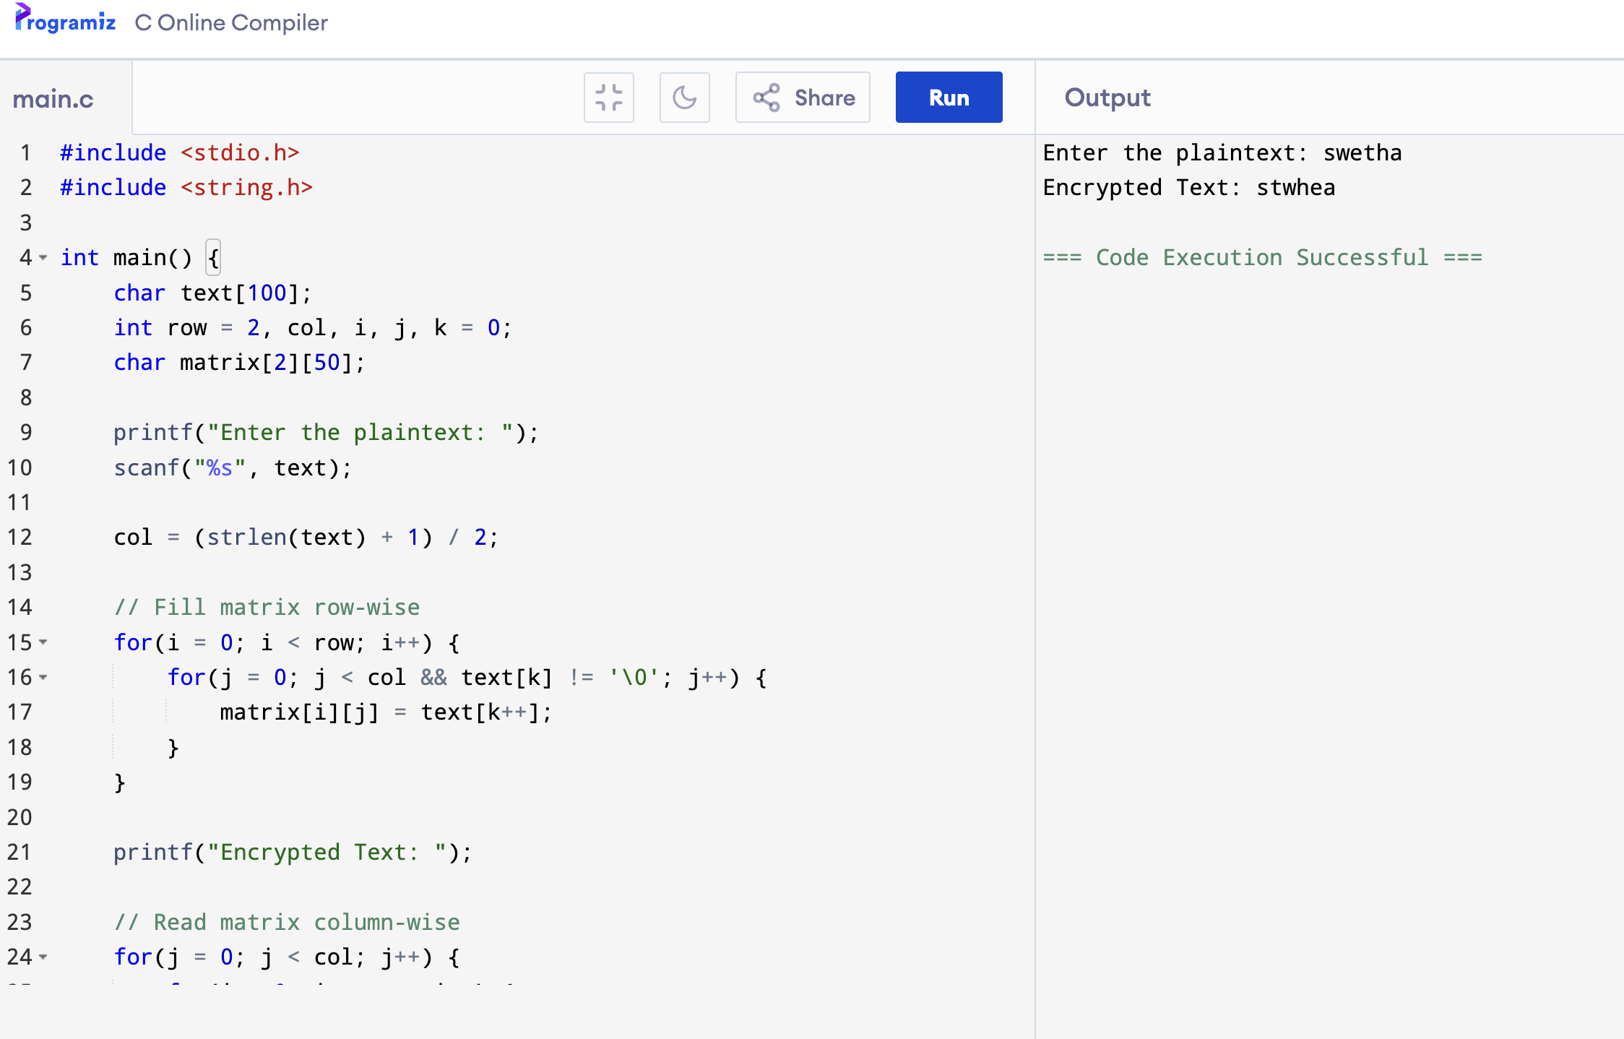
OUTPUT:

